**Overview of the analysis:**

The purpose of the analysis is to create a summary data frame that will show ride sharing data by city type (Rural, Urban & Suburban)

**Results:**

* Rural cities have the least number of drivers, rides, and total fares.
* Urban cities have the greatest number of drivers, rides, and total fares.
* Suburban cities are in the middle having the 2nd most drivers, rides, and total fares.
* Although Rural cities see the least number of drivers, rides & fares the have the highest average of fare per ride and fare per driver.
* Although the Urban cities command the most drivers, rides and fares they have the lowest average of fare per ride and fare per driver.

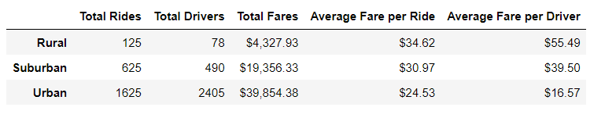

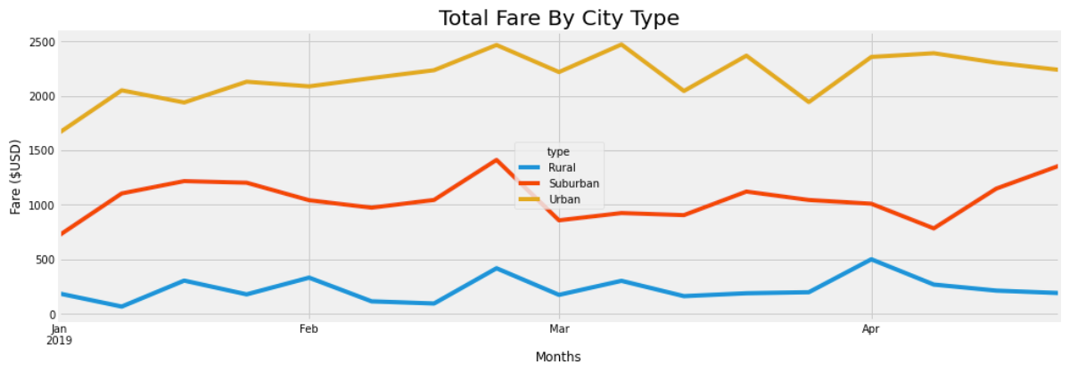

**Summary:**

From our data we can tell what kind of fares will be commanded based on what city type the passenger is catching a ride in. In conclusion we can effectively say that a rural area will command a higher fare because there are fewer workers that will come to this area, the travel time and distance is most likely longer making the average fare per ride & driver the most out of all city types.

**Recommendations:**

1. Have your drivers assigned to different city types based off what type of cities they typically work in.
2. Charge more per mile in urban cities because trips most likely are shorter and drivers don’t earn as much per trip.
3. Make small charge increases or decreases based off how many riders there are in the city during certain months.